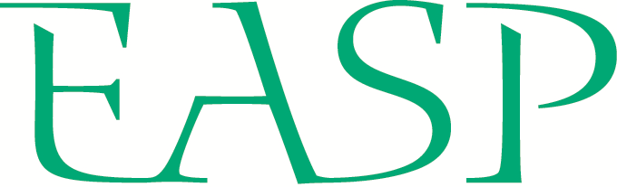
STUDENT APPLICATION FORM
EUROPEAN ASSOCIATION
OF SOCIAL PSYCHOLOGY
SUMMER SCHOOL

Institute of Social Sciences CSPS Slovak Academy of
Sciences & the Department of Psychology University
of Pavol Jozef Šafárik, Košice, Slovakia, 8th – 19th
of July 2024.
PERSONAL INFORMATION
Full name |  | Date of birth
University |  | Department
Email address |  | Nationality
Gender |  | Ethnicity

PHD INFORMATION
PhD topic
PhD start date: |  | Expected PhD completion date:
Name of supervisor
Institutional affiliation /position of supervisor

Please rank order the themed workshops you would like to attend [1 = highest preference, 5 = lowest preference].
For more details on each of the workshops and other planned activities, see the EASP Summer School website.
SOCIAL COGNITION
Workshop teachers: Hans Alves & Moritz Ingendahl
SOCIAL PSYCHOLOGY OF VIOLENT ETHNO-NATIONAL CONFLICTS
Workshop teachers: Ruthie Pliskin & Islam Borinca
SOLIDARITY AND SOCIAL CHANGE
Workshop teachers: Maja Kutlaca & Soledad de Lemus Martín
COGNITIONS AND ENVIRONMENTAL IMPACT
Workshop teachers: Cameron Brick & Karlijn van den Broek
REACTING TO INEQUALITY: SEXUAL AND GENDER IDENTITIES
Workshop teachers: Yasin Koc & Jenny Veldman

RESEARCH STATEMENT
Please provide a description of your research. Describe the phase of your PhD you are in presently (e.g., literature review, data collection), the work you have completed to date (e.g., number/type of studies), the status of this work (e.g., in preparation, under review, published), and your future research plans – max. 250 words
STATEMENT OF INTEREST IN THE 2024 EASP SUMMER SCHOOL
Please explain why you are applying for the 2024 EASP Summer School. Explain your motivation to participate (including reference to your preferred workshop/s), and your expectations on how your participation will contribute to your research goals and career development – max. 250 words

CURRICULUM VITAE – max. 2 pages, adjust boxes to suit

Research & publications (list published and accepted/in press papers first)
Conference presentations & invited talks
Awards, prizes, grants & other funding
Other skills, personal & professional development (e.g., teaching qualifications, specialist research techniques)

SUBMISSION OF APPLICATION
Please email your completed EASP Summer School application form by February 29th 2024 to the SASP secretary, Liz Summerell: sasp.secretary@gmail.com

The subject line of the email should include your full name: EASP2024 – Full Name
Please name this file using your last name and first initial as follows: Last_F_EASP2024

In addition to this application form, please arrange for your nominated referee (e.g., supervisor) to complete and send the Academic Recommendation form directly to the email address above.

WORKSHOP INFORMATION

Workshop 1: Social Cognition
This workshop will focus on the cognitive processes by which people form attitudes toward individuals and groups. This may include processes of information sampling, attention, memory, and information integration.

Workshop 2: The Social Psychology of Violent Ethno-National Conflicts
This workshop will focus on the psychological drivers and outcomes of violent ethno-national conflicts, psychological barriers to and interventions for conflict resolution, and the psychology of intergroup relations in conflictual and post-conflict societies. This may include processes ranging from attitudes and group-based emotions to behavior.

Workshop 3: Solidarity and Social Change
This workshop will explore social psychological approaches to allyship, cross-group solidarity, and collective action. By critically examining various instances of allyship, we will explore questions such as when and how allies can contribute to or undermine social change efforts.

Workshop 4: Cognitions and Environmental Impact
This workshop applies social psychology to environmental problems by studying perceptions and impactful behaviors. Previous research often overlooked behavior measure validity and non-psychological determinants. In this workshop, you will learn about mental models and objective behavioural tasks, and design new studies.

Workshop 5: Reacting to Inequality: Sexual and Gender Identities
This workshop will focus on how social identities, inequality, and stigma interact with each other, especially in the case of sexual and gender identities. We will draw upon a wide range of theoretical approaches to examine ways people react to inequality in order to improve disadvantaged groups' status as well as their well-being.

