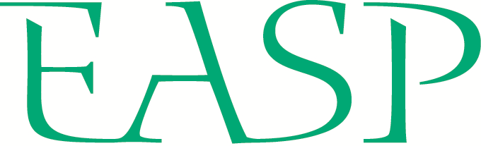
ACADEMIC RECOMMENDATION FORM
EUROPEAN ASSOCIATION
OF SOCIAL PSYCHOLOGY
SUMMER SCHOOL

Institute of Social Sciences CSPS Slovak Academy of
Sciences & the Department of Psychology University
of Pavol Jozef Šafárik, Košice, Slovakia, 8th – 19th
of July 2024.
PERSONAL INFORMATION
Full name |  | Email address
University |  | Department

Name of student being referred

ACADEMIC RECOMMENDATION

Please explain why this student’s participation in the 2024 EASP Summer School (and their chosen workshop/s) would benefit their research and career development. Refer to this student’s progress, current research plans, and any areas of their development to support your answer. You may wish to refer to professional activities beyond research that would support this student’s application (e.g., teaching, public engagement). – max. 250 words
SUBMISSION OF APPLICATION
Please email your completed EASP Summer School academic recommendation form by February 29th 2024 to the SASP secretary, Liz Summerell: sasp.secretary@gmail.com

The subject line of the email should include the student’s full name and the label “academic recommendation”: Academic Recommendation – Full Name
Please name this file using the student’s last name and first initial as follows: Last_F_AR

