‘It’s important to be curious’: 92yo UNE alum on psychology, values
Published 30 September 2022
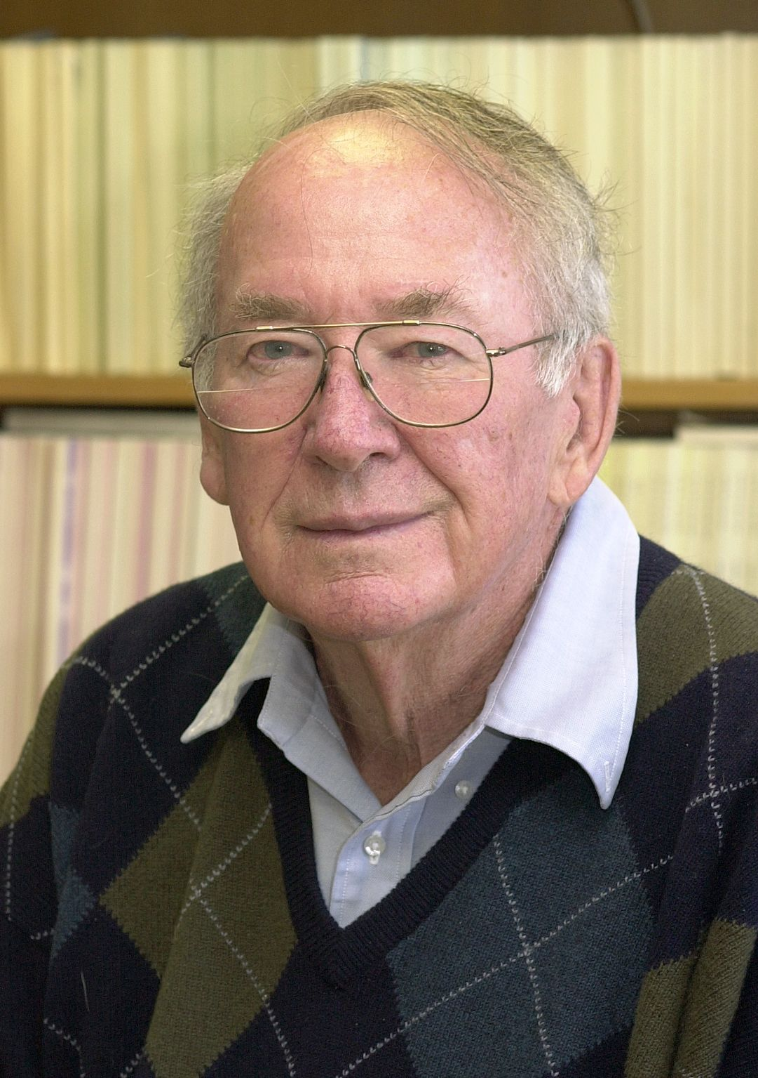
Image: Norm Feather started at the New England University College (the precursor to UNE) in 1947 on a teacher’s college scholarship.
At 92, esteemed psychology educator and researcher Professor Norm Feather AM belongs to an elite club. He may well be the oldest living alumnus of UNE. If not, he is certainly one of the most active of his generation.
Although he officially retired from academia in 2000, and says he is “a bit old for research now”, Professor Feather collaborated on a paper due to be published later this year and maintains a keen interest in social psychology – the subject that has engaged him throughout his illustrious career.
“I have a very curious mind and I have always been very interested in people, what their attitudes are and how they behave,” he says.
“Social psychology and the psychology of motivation were the two areas that I took a particular interest in. I think it’s important to observe what’s going on around you and to think about that.”
I think it’s important to observe what’s going on around you and to think about that.
Professor Feather’s contributions on the psychology of values and the psychological impact of unemployment have been influential internationally, as demonstrated by his high citation counts. His later work explored the social psychology of justice and human motivation, and Professor Feather pioneered research in Australia into “tall poppies” or high achievers. He is also a world authority on expectancy-value models of motivation.
Where it all began
Norm was a mere lad when he arrived at the New England University College (the precursor of the University of New England) in 1947 on a teacher’s college scholarship. He initially lived in a townhouse in Armidale, sharing a room with two other young men and travelling up to Booloominbah each day for meals and campus lectures.
“They were very old houses and the accommodation was basic, but it taught you how to cope and how to work with people,” Professor Feather says. “Catching the bus to Booloominbah early each morning and returning in the evening, they were long and sometimes cold days, particularly in winter.”
I loved living in college, and the university provided a wonderful community of people.
By the early 1950s he had almost completed his Bachelor of Arts with Honours when he became one of the first residents of the newly built Wright College and was later appointed a fellow and senior resident fellow.
NEUC and the fledgling UNE were still relatively small at the time. “It meant you knew lots of people and had many friends,” Professor Feather says. “It was a situation that led to a very communal atmosphere. I loved living in college, and the university provided a wonderful community of people.”
The student becomes the teacher
As well as completing his Diploma in Education (at the Armidale Teacher’s College) and Master of Arts with Honours at the newly autonomous UNE, Professor Feather launched his professional career at UNE, as a lecturer in 1952, and helped develop the distance education offering for psychology.
Progressing to a senior lecturer and then Associate Professor, he took leave in 1958 to complete his PhD with the University of Michigan as a Fulbright scholar (the first of two such scholarships), but returned to UNE in 1960 and gave another seven years’ service before joining what is now Flinders University. There, he became the foundation professor in psychology.
Professor Feather looks back on his years at NEUC and UNE with great fondness. “It was a very important part of my career, a very good testing ground, and where I first became interested in motivational models that might be applied to human behaviour,” Professor Feather says.
“NEUC produced a number of graduates who became very well known in their fields. For a small university college and relatively small regional university, it did very well.”
It’s important to be curious ... to worry at it like a dog worries a bone, until you have the answer that satisfies you.
An illustrious career
The author or editor of six books (the last published in 1999, on values, achievement and justice) and 230 published articles, Professor Feather was awarded a UNE Distinguished Alumni Award in 1998 and a year later earned the Australian Psychological Society’s Distinguished Science Contribution Award.
Honorary Doctors of Letters from UNE and Flinders University followed, and Professor Feather received an AM in 2016 for his significant service to higher education as an academic, author and editor, to the social and behavioural sciences, and to professional bodies.
He also has an Honorary Fellowship from the Australian Psychological Society and counts the International Society for Justice Research Lifetime Achievement Award among his greatest honours.
'I value people and family very much'
Professor Feather’s advice for younger scholars might equally be applied to life more generally: “It’s important to be curious; to work hard, obviously, but also to follow your interests and keep at it. To worry at it like a dog worries a bone, until you have the answer that satisfies you.”
And for a man who has spent his professional life studying values, what is it that Professor Feather now appreciates most in life?
“I value people and family very much,” he says. “I value achievement that has been well earned, that you deserve to have, and I always try to maintain a positive attitude.”
- Contact:
- UNE Social Media Team
- +61 2 6773 5114
- socialmedia@une.edu.au

