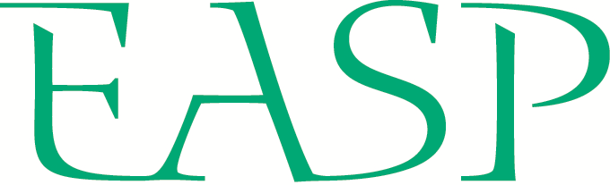
STUDENT APPLICATION FORM
EUROPEAN ASSOCIATION
OF SOCIAL PSYCHOLOGY
SUMMER SCHOOL

SWPS University of Social Sciences and Humanities,
Wroclaw, Poland, July 24th - August 6th 2022

PERSONAL INFORMATION
Full name |  | Date of birth
University |  | Department
Email address |  | Nationality
Gender |  | Ethnicity

PHD INFORMATION
PhD topic
PhD start date: |  | Expected PhD completion date:
Name of supervisor
Institutional affiliation /position of supervisor

Please rank order the themed workshops you would like to attend [1 = highest preference, 5 = lowest preference].
For more details on each of the workshops and other planned activities, see the EASP Summer School website.
IDENTITY AND POLITICS
Workshop teachers: Aleksandra Cichocka, Aleksandra Cisłak
INTERGROUP RELATIONS
Workshop teachers: Michał Bilewicz, Sylvie Graf
MEANINGS IN LIFE
Workshop teachers: Samantha Heintzelman, Wijnand Van Tilburg
MORAL JUDGEMENT AND BEHAVIOR
Workshop teachers: Shahar Ayal, Paul Conway
SOCIAL COGNITION
Workshop teachers: Hans IJzerman, Caterina Suitner

RESEARCH STATEMENT
Please provide a description of your research. Describe the phase of your PhD you are in presently (e.g., literature review, data collection), the work you have completed to date (e.g., number/type of studies), the status of this work (e.g., in preparation, under review, published), and your future research plans – max. 250 words
STATEMENT OF INTEREST IN THE 2022 EASP SUMMER SCHOOL
Please explain why you are applying for the 2022 EASP Summer School. Explain your motivation to participate (including reference to your preferred workshop/s), and your expectations on how your participation will contribute to your research goals and career development – max. 250 words
CURRICULUM VITAE – max. 2 pages, adjust boxes to suit

Research & publications (list published and accepted/in press papers first)
Conference presentations & invited talks
Awards, prizes, grants & other funding
Other skills, personal & professional development (e.g., teaching qualifications, specialist research techniques)

SUBMISSION OF APPLICATION
Please email your completed EASP Summer School application form by February 11th 2022 to the SASP secretary, Michael Thai: sasp.secretary@gmail.com

The subject line of the email should include your full name: EASP2022 – Full Name
Please name this file using your last name and first initial as follows: Last_F_EASP2022

In addition to this application form, please arrange for your nominated referee (e.g., supervisor) to complete and send the Academic Recommendation form directly to the email address above.

WORKSHOP INFORMATION

Identity and politics
This workshop will discuss how social identities in their different forms are linked to political beliefs, decisions and behaviors. The workshop will focus on current social and political problems such as populism, science denialism, and anti-environmentalism.

Intergroup relations
This workshop will deal with factors that shape intergroup relations such as language (e.g., grammatical forms, ethnic labels, derogatory rhetoric, gender forms) and experiences of intergroup contact (e.g., positive and negative direct contact, mass media, historical contact) or conflict (e.g., victimhood beliefs).

Meanings in life
This workshop will discuss how people create, experience, maintain, and protect a sense of meaning in life, and how this relates to motivation, well-being, emotion, interpersonal behaviour, and life outcomes.

Moral judgement and behavior
This workshop will be focused on ethical decision making. The topics discussed here will cover the dilemma between honesty and conflicting motives and contextual factors related to (dis)honest behavior. The workshop will also concentrate on how people make their sacrificial judgments and what is the role of morality in person perception.

Social cognition
This workshop will focus on how people interpret others, the self and social groups. It will also cover the role of additional factors that play a significant role in social cognition (i.e., social thermoregulation).

